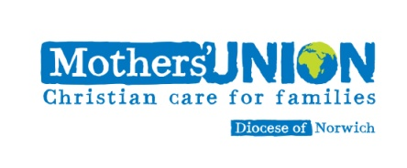
Membership Joining Form

Please only complete this form if you wish to join the Norwich Diocese Mothers’ Union

Name ………………………………………. (1)

Name ………………………………………. (2) (for Family membership)

Address ……………………………………………………

……………………………………………Post code………………..Telephone …………………..

e-mail ……………………………………………………………….

Diocesan Membership
For Branch affiliated members - Name of Branch ...........................

(For Family members only) to whom does this affiliation refer? Member 1 / Member 2

You may pay your subscription (Note 2) in any one of the following ways (please tick the box as appropriate):
by cash to the Branch treasurer □; by cheque made payable to Mothers Union - Norwich Diocese □;
by Standing Order □; by Bank transfer (Account No. 65432781; Sort Code 08-92-99 )(Note 4) □
2019 – Single Subscription £26.50 – Family Membership £50
-o-o-o-o-o-

Mothers Union Central Services (Mary Sumner House) requires each Diocese to send in a statistical return by 31st March, each year. It would help us enormously if you could put a tick in each box that refers to you in the statements below:

For second Family
Member only

You are ordained
You have re-joined the Mothers Union after leaving
You have transferred from another Diocese this year
You are an Indoor member
You are a man
You subscribe to ‘Families First’
You have children under 16

Please return this form with your subscription either directly to the Mothers Union Office (Diocesan House, 109 Dereham Road, Easton, Norwich NR9 5ES) or to your Branch who will forward it to the Office.

Please turn over for Notes

Note 1 All members of the Norwich Diocese Mothers’ Union are referred to simply as ‘Members’. Those who have always been Branch members are said to have a Branch affiliation (i.e. ‘belong to a branch’). Members who do not wish or cannot have a branch affiliation are the same as those previously referred to as ‘Diocesan members’. They will be kept in up-to-date contact with the Diocesan organisation by the Area Leader of the region where they live. Indoor members are those members who by virtue of age or incapacity cannot now attend meetings. Each Indoor member falls under the care of their current local branch.

Note 2 Cheques may be sent directly to the Norwich Mothers Union Office (with this completed form) or passed on to a Branch Treasurer, who will forward it to the Office

Note 3 If you pay income tax, you may gift-aid your subscription. Details of this are given on a separate sheet.

Note 4 The Mothers Union (Norwich Diocese) banks with the Cooperative Bank. If paying by Bank Transfer, it is essential you put your name in the Reference box, otherwise we shall not be able to trace your subscription.

