Raglan sleeved variation on Premature Baby V-neck cardigan, size 10"
Submitted by Mary Garrett

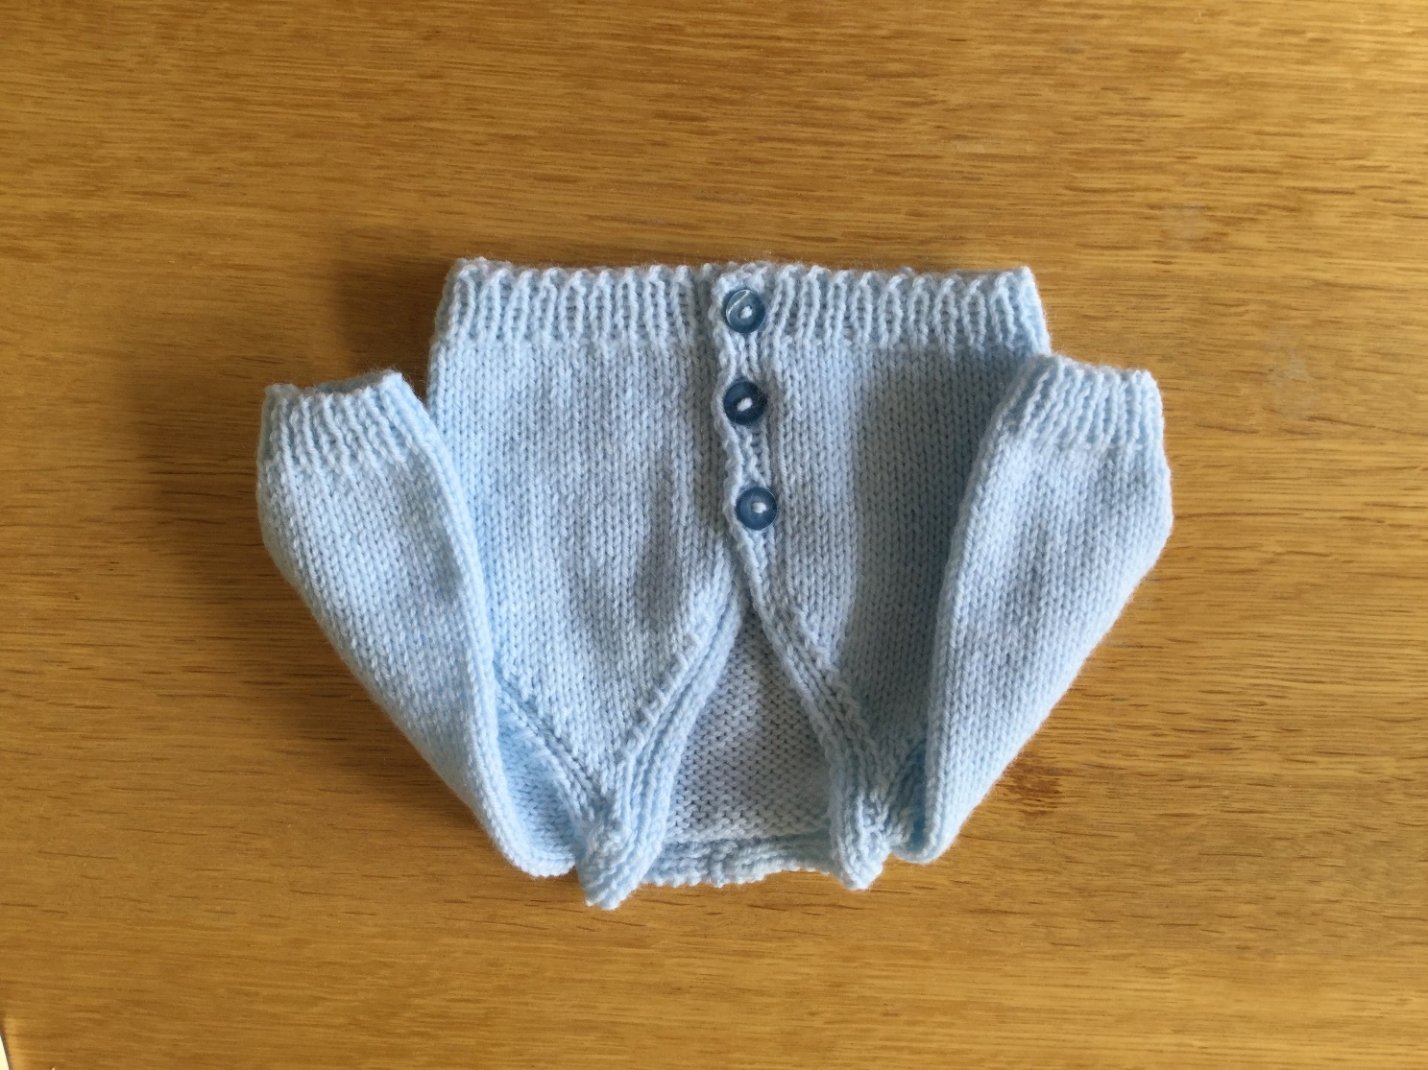

Many people prefer a raglan sleeve for baby wear. My challenge has been to simplify and adapt an existing pattern, while fitting it to Doris Lord’s sizing. It has taken me months, but on Saturday I finally woke up knowing how to do it.
Mary Garratt
14th March 2000
Approx 40gm 4ply yarn. I pair size 3mm (size 11) and 1 pair 3¼mm (size 10) needles. 3 small buttons.
Back
Using 3mm needles, cast on 43sts.
Work in moss stitch for 6 rows.
Change to 3¼mm needles and stocking stitch. Work 24 rows. [End of row 30]
Raglan Shaping
Cast off 1 stitch at beginning of next 2 rows. Decrease 1 stitch at each end of next and every knit row until 21 stitches remain. Purl one row.
Next row: K1, sl.1, k2tog. psso, knit to last 4 sts. k3tog. k1
Next row: Purl
Cast off remaining 17 stitches.
Left Front
Using 3mm needles, cast on 25sts. Work 6 rows in moss stitch. Change to 3¼mm needles and stocking stitch with moss stitch border, thus:
‘Pattern’
Right side rows: knit to last 4 stitches p1, k1, p1, k1
Wrong side rows: k1, p1, k1, purl to end.
Work to end of row 30 (i.e. 6 rows moss stitch and 24 rows of ‘pattern’ as above)
Shaping for Raglan Sleeve Edge and for Neck Slope
Keeping moss stitch border correct, cast off 1st at beginning of next right side row. [This is row 31 for left front and row 32 for right front]
Then decrease 1 stitch at sleeve edge and 1 stitch inside moss stitch border on every right side row until 8 stitches remain.
Continue to decrease at sleeve edge only until you are left with the 4 moss stitches.
Work 22 rows in moss stitch on these 4 stitches. Cast off in moss stitch.
Right Front
Work as left front, but change ‘pattern’, and add buttonholes, as below:
Buttonholes
Work into moss stitch border, on rows 3, 11 and 21, thus: K1, p1, yarn round needle, p2tog. Work rest of row as normal.
‘Pattern’
Right side row: k1, p1, k1, p1, knit to end
Wrong side row: Purl to last 3sts. k1, p1, k1
Sleeves (knit 2)
Cast on 27sts. using 3mm needles.
Work 6 rows moss stitch. Change to 3¼mm needles and stocking stitch.
Increase 1 stitch at each end of 3rd and every following 4th row to 35 stitches.
Work 7 rows straight [ie to end of row 28].
Cast off 1 stitch at beginning of each of next two rows (33 sts).. Then decrease by 1 stitch at each end of next and following right side rows until 15 stitches remain, ending with a purl row.
Next row: k1, sl.1, k2tog, psso, knit to last 4 stitches k3tog, k1
Next row: Purl
Repeat these two rows once and then cast off remaining 7 stitches.
To Finish
Join raglan, side and sleeve seams. Join ends of neckband together and sew in place across sleeve top and back neck. Sew on buttons.

