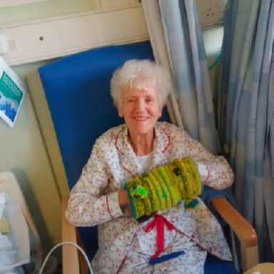

ROLE DESCRIPTION FOR DEMENTIA AID PROJECT LEADER
The Project Leader for Dementia Aid coordinates the crafting of articles such as Activity Aprons, Activity Muffs and Knee Blankets for use by dementia sufferers in care homes and hospitals by:-
- Keeping a record of where articles are knitted or sewn.
- Maintaining a stock of articles to meet requests direct from the care homes or hospitals or other sources, for example via the clergy.
- Making arrangements to deliver articles requested. This can be done personally, by members visiting a care institution, or any other route of the Project Leader’s choosing.
- Maintaining an electronic and/or hard copy record set to show where articles are made, how many, and to where the finished articles have been sent.
- Keeping abreast of new articles for dementia sufferers and obtaining patterns and instructions for crafting.
- Ensuring that new patterns and crafting instructions are added to the Mothers’ Union Diocesan website through the Diocesan Secretary.
- Seeking to encourage branches and members to make aprons, muffs, blankets and any other appropriate articles.
- Liaising with the Unit Coordinator on progress or any problems regularly, and writing a short report when requested.

