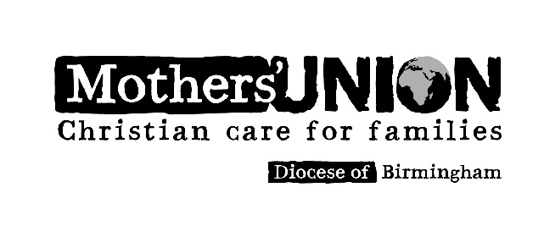
PRESIDENT: JACKIE BROCKLEBANK

MOTHERS’ UNION OFFICE
CHURCH OF ENGLAND
1 COLMORE ROW
BIRMINGHAM B3 2BJ REGISTERED CHARITY 1065815

Birmingham Mothers’ Union invites branches to apply for funding from the Diocese following our successful fundraising initiative ‘Mums in Brum’. Funding is to be used to start new projects or initiatives to further the aims and objects of the Mothers’ Union. Trustees will consider applications at their discretion up to a sum of £150. For an informal discussion please email the office to speak to a Trustee.
Application for funding from Mums in Brum Fund
Date of Application
Please tell us how and when you will use the funding

How will you sustain this project?

How does your project further the work of the Mothers’ Union in your local area?

Which object does this project support? Please tick one or more
To uphold Christ’s teaching on the nature of marriage and promote its wider understanding
To encourage parents to bring up their children in the faith and life of the church
To maintain a worldwide fellowship of Christians united in prayer, worship and service.
To promote conditions in society favourable to stable family life and the protection of children
To help those whose family life has met with adversity.

How much funding are you seeking?
Please give us a broad breakdown of what you will spend the grant on.

Please supply your bank account details.

If successful we will contact you for feedback on the project and its impact. We would also like to publicise details of what you have done.
Signed:…………………………………………………….
Position……………………………………Branch…………………………………….
Please return this form to the Mothers’ Union office - address overleaf
Version 1 June 2016

